Great Lake Mapping & Documentation Method

1. Load shoreline, transects, any WHAFIS or runup modeling output, LiMWA location, 100yr_Floodplain, terrain and other modeling files to mxd. Draw seamless mapping method polygons using “Auto Complete Polygon” tool over areas of different topography. (use contour in terrain database help make sure polygons covers all areas potentially affected by runup). Usually one mapping method polygon is drawn for each transect unless there are multiple mapping methods applied to different sections of one transect. Sheltered area at back of transect usually would need one polygon for itself. Transitioning zone between runup dominated area and WHAFIS/SWEL dominated area would also need one polygon. If the BFE difference between two transects are more than 3ft, please make the transitioning mapping method polygon between wide enough to contain a transiting zone.

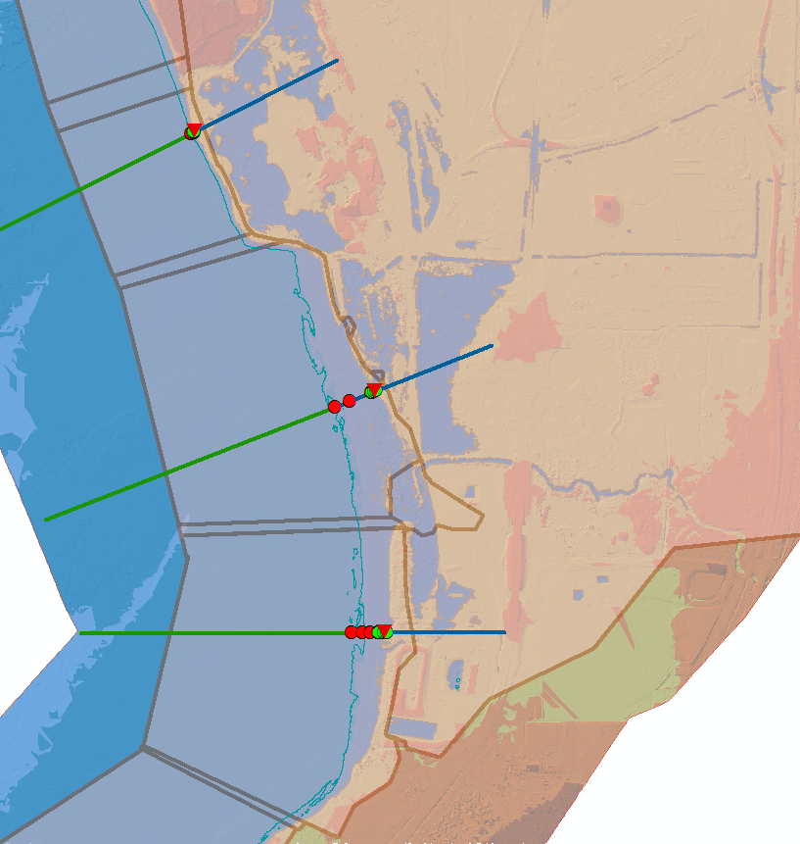

For each mapping method polygon, input the following information:

**HYDROID (Transect #)**: Input this field with the number of the transect that it’s runup/WHAFIS result is used to map one mapping polygon. If that transect is not directly overlapping with this mapping method polygon, please write “transect# borrowed”. For area between transects, leave this field blank.

**Highest_WH** : Input this field with the highest wave crest in Scenario4’s WHAFIS output

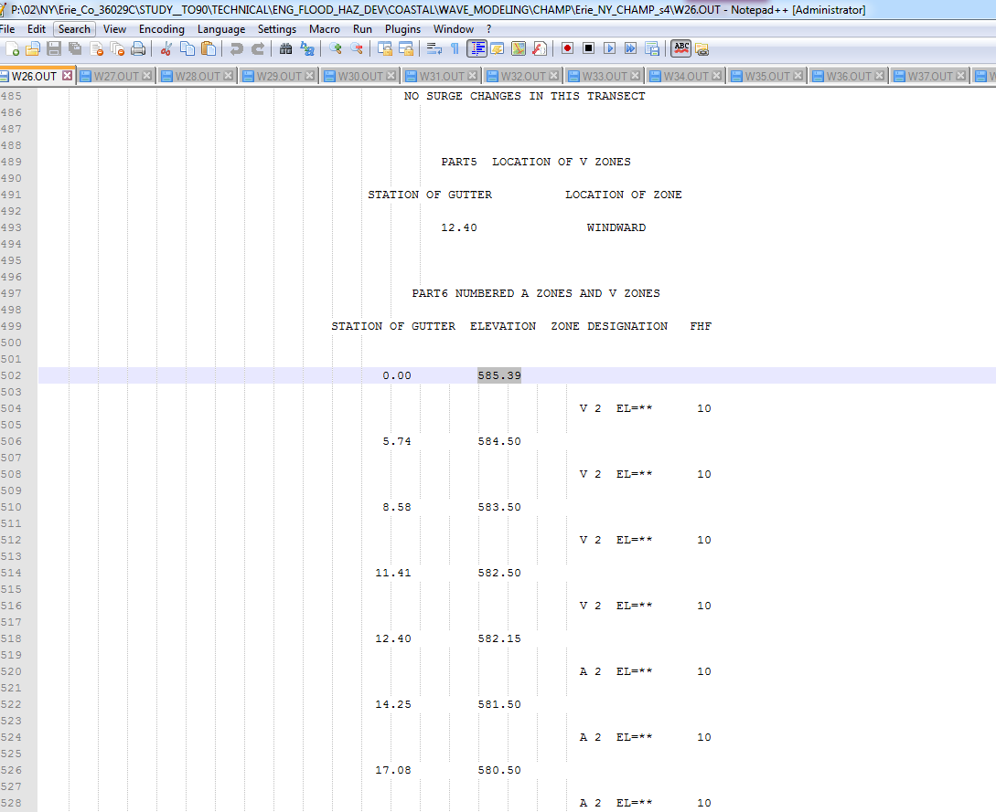

**MAP_1stBFE:** Compare the final runup and **Highest_WH,** input the higher value.

**MAP_1stSOU:** Input the source **of MAP_1stBFE** (WHAFIS or RUNUP)

**##MAP_1stZON:** If WHAFIS’s first zone is VE, input “VE”. If WHAFIS’s first zone is AE and WHAFIS dominates, input “AE”. If WHAFIS’s first zone is AE but runup dominates, check if the controlling wave height is more than 3ft, if not, input “AE”. If runup dominates and controlling wave height is greater than 3 feet, input “VE”.

**100Bry_ele** : Input this field with the water elevation at 100yr boundary at non-eroded transects. If runup dominates at 100yr boundary, this value is the final runup (after plateau method and 3ft above crest capping rule). If 100yr boundary is mapped to 100yr SWEL or transect is eroded leave this field 0. If there is no 100yr boundary needed, leave this field 0 as well.

**100Bry_Def**: Input description of how 100yr boundary is defined within this mapping method polygon.

**VAGut_ele** : Input this value when **MAP_1stZON** is VE. When WHAFIS dominates, put the terrain elevation at the first AE station of WHAFIS output. When runup dominates, put (final runup-3ft). When a transect is eroded and runup dominates, leave this field 0 and note the station of VA gutter in **VAGut_Def**. When overtopping rate Q>1, VA gutter should be mapped at 30ft behind crest, leave this field 0 and describe AO zone extent station in **100Bry_Def**. When overtopping rates Q>1, VA gutter should be mapped at 30ft behind crest, leave this field 0. When overtopping rates Q is between 0-1, put VA gutter at (final runup-3ft) and describe AO zone extent station in **100Bry_Def.** (use the starting wave condition of each transect as the wave condition at toe of each transect for overtopping calculation)

**VAGut_Def**: Input description of how VA/AE gutter is defined within this mapping method polygon.

**LIMWA_ele:**  field is input with the water elevation at the 1st 1.5 wave point. Only input this value when WHAFIS’s first zone is VE and no runup is mapped. If transect is eroded or VA gutter station is based on overtopping result or WHAFIS’s first zone is AE, leave this field 0. If WHAFIS’s first zone is AE, but controlling wave height is more than 3ft, it might be ok to map LiMWA based on engineering judgment.

**LIMWA_Def**: Input description of how LIMWA is defined within this mapping method polygon.

**Notes:** Input any other description about mapping method within this mapping method polygon. Suggest to write down final runup value and runup method in this field.

**ID** field is result of ([FID] +1 )*1000 after all polygons have been drawn for one county.

2. After mapping polygon is final, use tool “Polygon to Raster” to create rasters for **100Bry_ele, VAGut_ele** and **LIMWA_ele** (only select the non-zero record polygons for each value)**.** Save those rasters in individual folder under mapping folder.

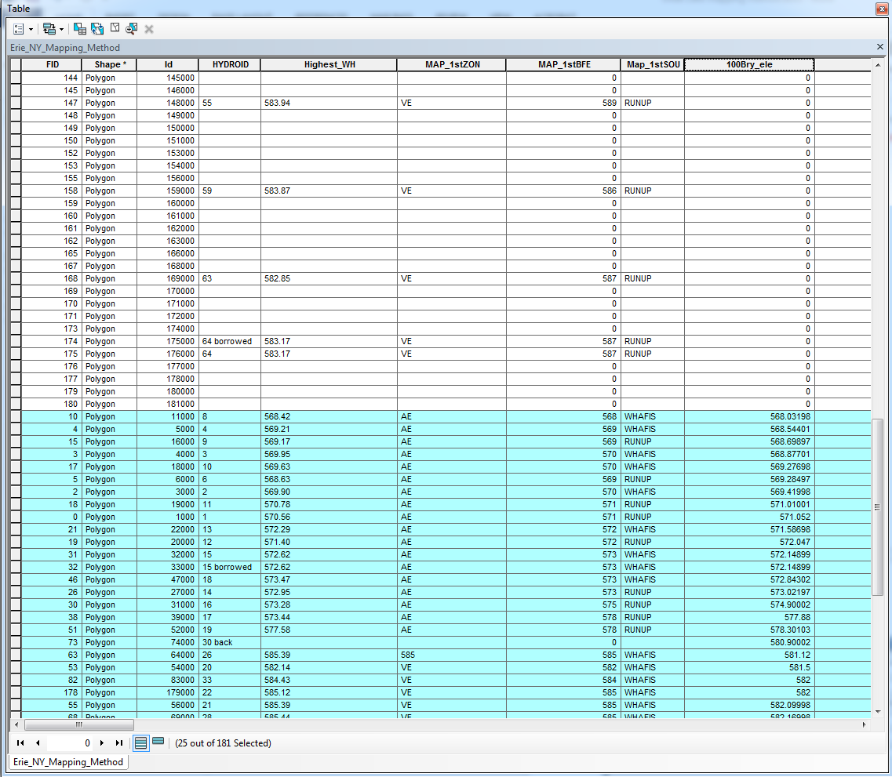

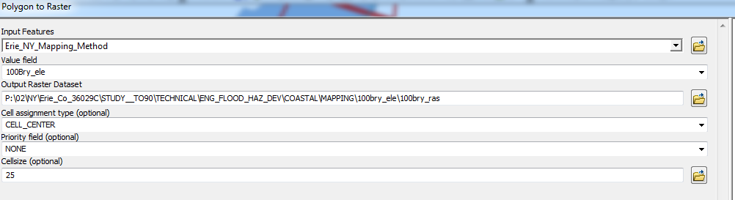

3. Convert those rasters to tin using batch processing and the following settings. Output to each value’s folder

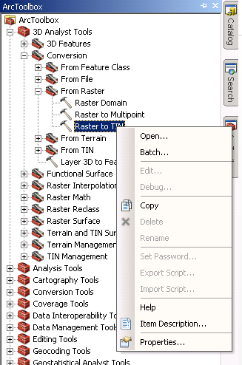

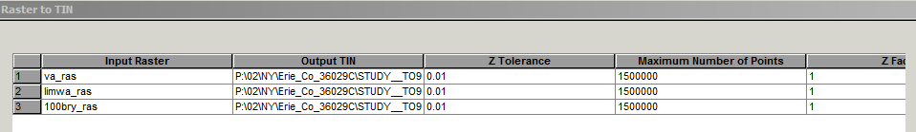

4. Use batch “Surface difference” tool to calculate difference between each tin and terrain (this process takes a lot of computer memory). Output to each value’s folder.

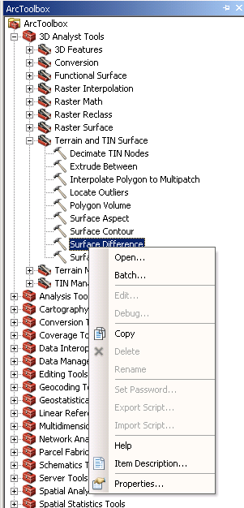

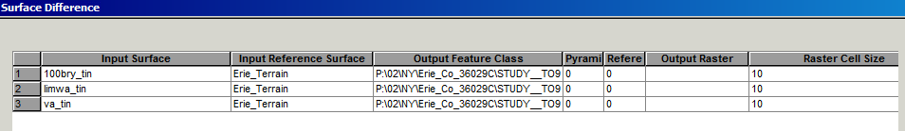

5. Use tool “Polygon to Line” to convert those shapefiles to line.

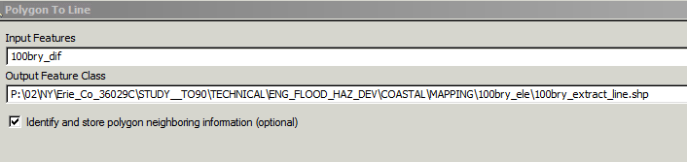

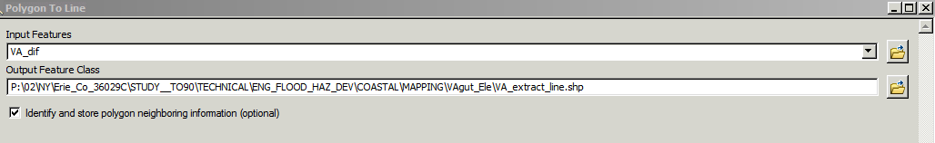

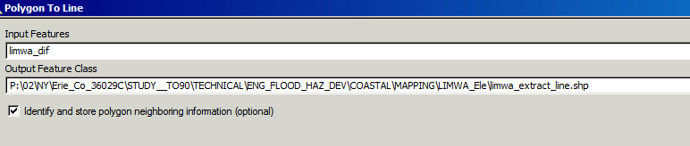

Check each polygon to make sure extarcted lines look ok. Sometimes polygons need to be reshaped to extend far enough to cover all areas affected by runup. Sometimes, a portion of shoreline might be very different from adjacent area and need a polygon especially for that area. Sometimes need to re-arrange the position of transition area. Make necessary changes and start again from step 2.

6. Convert 100yr floodplain smooth polygon and 500yr floodplain smooth polygon to polyline. This step assumes floodplain polygons have been created already. They are based on the frequency analysis of the maximum storm surge levels for each storm simulated.

Then convert mapping method polygon shapefile to polyline. Use field calculator to assign LEFT_FID to be 9999 for mapping method polyline shapefile.

Copy mapping method polyline shapefile to 100yr polyline. Save edits and select all, then apply “Planarize Lines”:

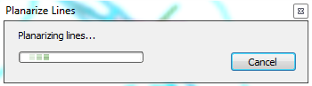

Then select parts with LEFT_FID=9999

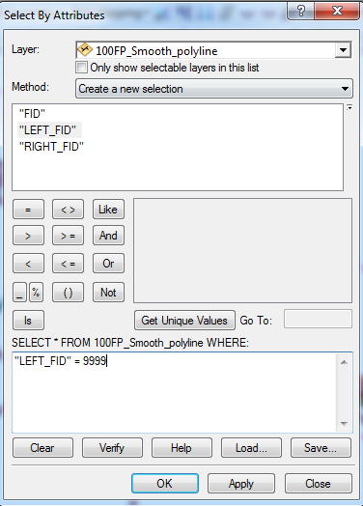

Delete selected. Save edits and stop editing.

Do the same for 500yr polyline

7. Copy and paste corresponding lines to a mapping database. Edit following descriptions in mapping method polygon. Make sure to tie-in at boundary of each mapping method polygon. Also 100yr raw FP should be turned on all the time to make sure the interpolated boundary follows trend of 100yr FP and keeps outside of 100yr FP. At the same time, label mapping method polygons with “[Id]& [MAP_1stZON] & [MAP_1stBFE]” , so you can easily check in the attribute table how to map each area. Sometimes the boundary extracted to runup elevation could be messy, need to manually clean it up.

8. In the process of mapping, if you find mapping method polygon need to be revised, suggest to mark the polygon number and continue to next transect. After going through all transects, edit all marked mapping method polygons and regenerate rasters/ lines again altogether.